**Mini Project Report On**



**Weather Application**

**Department of Information Technology**

**Submitted By: Himanshu Tiwari (2200910139007)**

JSS Academy of Technical Education, Noida

Dr A P J Abdul Kalam Technical University, Lucknow

### DECLARATION

I hereby declare that the work presented in this report entitled “Weather App using **“HTML, CSS and Java Script”** in partial fulfilment of the requirements for the award of the degree of Bachelor of Technology in Information Technology submitted in the department of Information Technology, JSS Academy of technical Education, Noida is an authentic record of my own work carried out over a period from November 2023 to December 2023.

The matter embodied in the report has not been submitted for the award of any other degree.

(Student’s Signature) Himanshu Tiwari (2200910139009)

(Supervisor Signature) **Mr. Birendra Verma** Dated:

### CERTIFICATE

This is to certify that Project Report entitled **“Weather Application”** which is submitted by **Himanshu Tiwari (2200910139007)**, fulfillment of the requirement for the award of degree B. Tech. in Department of Information Technology of JSS Academy of Technical Education, affiliated to Dr. A.P.J. Abdul Kalam Technical University, Lucknow is a record of the candidates own work carried out by them under my/our supervision. The project bodies result of original work and studies carried out by the students themselves and the contents of the project do not form the basis for the award of any other degree to the candidate or to anybody else.

**Table of Contents**

Abstract i

Acknowledgement ii

List of Figures iii

1. Chapter 1 Introduction
   1. Problem Statement 1-2
   2. Motivation 3
   3. Objective 4
   4. Weather Api 5
2. Chapter 2 Literature Review
   1. Previous Related system 6
   2. Need and advantages of app 7
3. Chapter 3 Tools and Technology used
   1. HTML,CSS and Javascript 8-10
   2. Software and Hardware Requirements 11
4. Chapter 4 System Development
   1. Data Flow Diagram 12
   2. Use Case Diagram 13
   3. Activity flowchart 14
   4. Sequence Diagram 15
5. Chapter 5 Conclusion and Future Scope
   1. Conclusion------------------------------------------------------------------------18
   2. Future Scope 19

References 203



#### Abstract

Since the 19th century, mankind has struggled to predict the weather of a particular area. Weather forecasting is a science using which people can predict the weather of an area for a particular location and time.

Over the years, scientists have discovered weather patterns using factors like humidity, winds, clouds, temperature, sea level etc. and now the weather predictions are more efficient than before, due to the use of advance technologies and algorithms. Even though there are many advance techniques and technologies, the web apps are very complicated for everyone to use. Especially for the illiterate people.

Many of the farmers depend on the weather, which plays a big role in determining the future of their crops. Many time they are not able to use technologies accordingly, and hence I decided to make an app which would show the main details like probability of rain, temperature, humidity etc just on clicking the app, no other steps required. The app would only require a stable internet connection and GPS.

### ACKNOWLEDGEMENT

I have put a lot of effort into this project. But this was not possible without the kind support and help of many people. I thank all of them sincerely. I am greatly indebted to my project supervisor Dr. Meena Arora for providing me with all the information regarding the project titled – Weather App using Html , Css, Javascript.

I am also thankful to JSS Academy of Technical Education, Noida for providing me with all the latest technologies, thus, comforting me with the project.

Again, I owe my profound gratitude to our project guide, for not only helping me with the project but also developing a keen interest in the same during its progress.

Himanshu Tiwari (2200910139009)

Dated:

### LIST OF FIGURES

Fig 1 Level Zero Data flow diagram Fig 2 Level one Data flow diagram Fig 3 Use Case Diagram

Fig 4 Application Flowchart Fig 5 Sequence diagram

## Chapter 1: Introduction

Nowadays we face a huge problem that knowing real weather status instantly in such a place we need to know. It is often complex and challenging skill that involves observing and processing vast amount of data Weather systems can range from small, short lived thunderstorms only a few miles in diameter that last a couple of hours to large scale rain and wind up to a thousand miles in a diameter, and lasting for days. We have another problem in weather forecasting. To do this effectively technology can help a lot. In this app is developed with the help of HTML,CSS , Javascript and API which will help the user to get to know about realtime weather updates of a particular place.

To summarize and brief in short, Weather App is the application of science and technology to predict the conditions of the atmosphere for a given location and time. People have attempted to predict the weather informally for millennia and formally since the 19th century. Weather forecasts are made by collecting quantitative data about the current state of the atmosphere, land, and ocean and using meteorology to project how the atmosphere will change at a given place. It is very important to get educated on the current weather situation of a particular location as preferred since it affects the day today life of everyone. It is more effective if we can get quickly updated on current weather status of a required location, as it makes it easy to handle not only our activities, but also our livelihoods too. A huge problem that we are facing nowadays is inability to know real weather status along with few days weather prediction in such places.

Forecasts based on rain and temperature helps us in agriculture. Since outdoor activities are severely curtailed by heavy rain, snow and wind chill, forecasts can help us to plan activity around these events and the plan ahead and survive them. The US spends billions every year on weather forecasting.

#### Problem Statement

Weather forecasts are used by both private and government industries to plan a wide range of daily activities, protect life or properties. Some of the natural disasters which cause a lot of damage to human life on earth are high wind, flood, cyclone, smoke, fire and fog. Presently, severe advisory and alerts are determined by MOSDAC (Meteorological and Oceanographic Satellite Data Archival Centre) [5].

The biggest problem many people face in this world is that many people are not able to use complex apps, they just need to click and know the weather at a particular time. Not all the smart phones have the features to have a google widget to show the weather.

Hence this app will just require the user to click on it and it would show the current weather details to the person.

All that you would require would be a stable internet connection as well as GPS, which are found in almost all the phones now a day.

The data of the weather will be fetched by an open source website [4] and it would be displayed on the screen of the phone in a user friendly way, so that every person could view it without many confusing steps. In the later versions of this app, we could also add some more features like multiple languages to view the weather, but for now it would be seen only in English.

It is important to first understand why people need to find the weather information and where do they turn up to for finding this information. The use and understanding of weather is interrelated and they both affect each other.

Lazo et al, did a study on sources and personal interpretation of weather [3] , where he looked at thelocations for which people obtain forecasts, individual perception of the important characteristics of a forecast, and the decisions made from the gathered information.

#### Motivation

The motivation behind developing The Weather App stemmed from a genuine desire to address the daily challenges individuals face in dealing with unpredictable weather conditions. Several key motivational factors guided the initiation and development of this project:

**User-Centric Approach:** Understanding User Needs: Recognizing the universal impact of weather on daily activities, the project aimed to create a solution that directly addresses the needsof users who seek accurate and timely weather forecasts.

**Empowering Users:** Enhancing Decision-Making: The project's motivation lies in empowering users to make informed decisions based on reliable weather predictions. Whether planning outdoor events, travel, or daily routines, The Weather App seeks to provide users with the confidence to navigate their lives with greater certainty.

**Innovation and Technology:** Leveraging Technological Advances: The motivation to harness the power of technology, including HTML, CSS, JavaScript, and a Weather Data API, reflects acommitment to delivering a cutting-edge solution. By integrating these tools, the project aimed to create an innovative and efficient weather forecasting application.

**Improving Accessibility:** Making Weather Data Accessible: Recognizing that accessing weatherinformation should be convenient and user-friendly, the project aimed to design an application that is easily accessible to a broad audience.

**Continuous Improvement:** project is driven by a commitment to continuous improvement, with a focus on refining features,incorporating user feedback, and staying adaptable to emerging technologies.

**Community Impact:** The project seeks to create a sense ofcommunity engagement by considering user feedback, integrating crowd sourced data.

3

#### Objective

There are various areas where weather forecast is used. The aviation industry is sensitive to weather, hence, accurate weather reports are required to manage and control the air traffic. Farmers rely on weather conditions to manage their work throughout the day.

Forestry department requires information regarding wind, rain, and humidity in order to control the wild fires. Electricity department also relies on this to predict the demand. Other commercial companies also pay for weather forecasts so they can increase their profits or avoid large losses. The main objective of this app is to show weather of a region in a user friendly manner, so that it is easy to be viewed by majority of the people. The scope of this app will not be too broad. On the contrary, it will be narrowed down to few functions which are mainly needed. The main functions involve temperature and probability of rain

This project will serve the following objectives :

* + 1. Time to time updated weather
    2. App shows Humidity and wind speed
    3. Predict Next 5 days temperature
    4. Changes weather in every hours as according to weather updated
    5. Provides accurate data information about weather.
    6. User can search weather anytime and anywhere.
    7. Any places data can be search and provide information as according to weather.
    8. Help user to travel.
    9. Help User to make future plans for holidays.

### WEATHER API

A weather API is an Application Programming Interface that allows weather data to be queried from scripts and code. Good weather APIs provide both historical weather data and forecast data via an easy-to-use, well-defined programming interface.

#### Why use a weather API

A weather API is ideally suited for use cases that need large volumes of weather data or need to access weather data in an automated way. For example, if you want to make a script that [loads weather data into a corporate data warehouse](https://www.visualcrossing.com/resources/documentation/weather-data-tutorials/how-to-load-historical-weather-data-into-any-database/) to match against historical sales metrics, using a weather API in your ETL script is the perfect solution. If you are creating an app that needs to [combine user activity and weather conditions at the time of that](https://www.visualcrossing.com/resources/documentation/weather-api/how-to-show-weather-data-in-an-outlook-add-in/) [activity,](https://www.visualcrossing.com/resources/documentation/weather-api/how-to-show-weather-data-in-an-outlook-add-in/) a weather API allows you to retrieve that exact weather conditions at any given time and location directly in your code. If you are [planning the inventory, marketing, and](https://www.visualcrossing.com/resources/blog/how-to-use-weather-forecast-for-visual-marketing-retail/) [staffing levels at your](https://www.visualcrossing.com/resources/blog/how-to-use-weather-forecast-for-visual-marketing-retail/) [small business locations,](https://www.visualcrossing.com/resources/blog/how-to-use-weather-forecast-for-visual-marketing-retail/) a weather API can be used from within [Excel](https://www.visualcrossing.com/resources/documentation/weather-data-for-excel-and-google-sheets/parameter-based-web-queries-in-excel/) or [Google Sheets](https://www.visualcrossing.com/resources/documentation/weather-data-for-excel-and-google-sheets/how-to-add-weather-data-to-google-sheets-using-a-dynamic-weather-query/) so than you can dynamically adapt your business based on the forecast conditions and how they apply in your specific case.

The use cases for a weather API are only limited by your business needs and imagination. There are thousands of ways to use weather data ranging from solar energy [production](https://www.visualcrossing.com/resources/documentation/weather-data/how-to-obtain-solar-radiation-data/) to [shipping](https://www.visualcrossing.com/resources/blog/easy-weather-lookups-for-shipments-logistics/) to [vacation planning.](https://www.visualcrossing.com/resources/blog/will-the-weather-be-nice-on-my-vacation/)

**EXAMPLES OF WEATHER API’s:** Open Weather provides daily weather information from its API using the icon field. This icon field has different values (01d, 02d, 10n etc...) corresponding to different weather situations: clear sky, few clouds, scattered clouds...

For example 10n is associated with light rain.

## Chapter 2: Literature review

#### Previous work or related systems

Before we begin to create a new it is important to study the system that will be improved or replaced (if there is one).

Following are the problems associated with the previous project which led to the creation of the proposed project:-

1. **Not user-friendly:** The existing system is not user-friendly because the information like humidity cloud and wind etc. are not in one place.
2. **Lack of information provided**: The apps just provide the temperature of few days but the temperature is not enough to plan something. We should also get some extra information like humidity, wind speed etc.

Functional requirements are the requirements that describe the functionalities of the system elements. It may involve functional user requirements or functional system requirements. For example:

1. The operator shall be able to input the region to the system to view the desired weather parameters.
2. The system shall provide the following weather parameters: temperature, pressure, wind speed, date / time and humidity.

#### Need for app :-

Weather is something everybody deals with, and accurate data about it like what is coming can help users to make informed decisions. With weather apps for iOS and Android, people can exactly know when to expect a change in the weather conditions. Weather apps can give urgent alerts too.

Undoubtedly, weather forecasting has come a long way, helping people to know about weather conditions. So, if you are in an area where weather frequently changes from sunny to torrential rain in a matter of minutes, then what is the easiest way to make sure to be prepared? A suitable answer is a weather application.

##### Advantages of the our app :-

* + 1. **Real-Time Data**

One of the biggest **advantages of weather apps** and also the reason why people have been going in for weather stations is because of the ability to get their information in real-time.

##### Accurate Local Forecast

In reality, the meteorological department may be located far from your home and ***weather forecasts*** are made for regions, not a specific area.

##### Ease to Use

Ease to use is definitely a big advantage of the weather monitoring system. Weather stations like all other weather devices are designed to be efficient and straightforward, therefore, everyone can use them.

##### Helps to make Decision

Our app provides the temperature of next 5 days which allows user to plan their activities accordingly.

## Chapter 3: Tools and Technologies used

#### HTML, CSS and Java Script

##### HTML

The **Hyper Text Markup Language** or **HTML** is the standard [markup language](https://en.wikipedia.org/wiki/Markup_language) for documents designed to be displayed in a [web](https://en.wikipedia.org/wiki/Web_browser) [browser.](https://en.wikipedia.org/wiki/Web_browser)

[Web browsers](https://en.wikipedia.org/wiki/Web_browser) receive HTML documents from a [web server](https://en.wikipedia.org/wiki/Web_server) or from local storage and [render](https://en.wikipedia.org/wiki/Browser_engine) the documents into multimedia web pages. HTML describes the structure of a [web](https://en.wikipedia.org/wiki/Web_page) [page](https://en.wikipedia.org/wiki/Web_page) [semantically](https://en.wikipedia.org/wiki/Web_page) and originally included cues for the appearance of the document.

##### CSS

CSS stands for Cascading Style Sheets. It is a style sheet language which is used to describe the look and formatting of a document written in markup language. It provides an additional feature to HTML. It is generally used with HTML to change the style of web pages and user interfaces. It can also be used with any kind of XML documents including plain XML, SVG and XUL.

CSS is used along with HTML and JavaScript in most websites to create user interfaces for web applications and user interfaces for many mobile applications.

##### JavaScript

JavaScript is a dynamic computer programming language. It is lightweight and most commonly used as a part of web pages, whose implementations allow client-side script to interact with the user and make dynamic pages. It is an interpreted programming language with object-oriented capabilities.

JavaScript was first known as **Live Script,** but Netscape changed its name to JavaScript, possibly because of the excitement being generated by Java. JavaScript made its first appearance in Netscape 2.0 in 1995 with the name **Live Script**. The general-purpose core of the language has been embedded in Netscape, Internet Explorer, and other web browsers.

#### How HTML,CSS and JAVA SCRIPT is used in our app ?

HTML defines the structure of your content, CSS determines the style and layout, and JavaScript makes the content interactive; therefore, it makes the most sense to learn them in that order. JavaScript incorporates valuable skills such as object-oriented, functional, and imperative styles of programming.

##### How to load weather data in JavaScript using Fetch API

Step 1 – set up a Weather API account. Step 2 – create a Weather API request.

Step 3 – create a JavaScript script to retrieve weather data. Step 4 – process the response.

#### Alternative technologies that can be used for app

There can be multiple technologies that can be used for our app such as

* + - 1. React Js
      2. PHP
      3. Kotlin
      4. Typescript

**Why HTML,CSS And Javascript is preferred over above technologies**

**?**

HTML’s functionality lies in its simplicity and universality. It’s the fundamental language of the web and forms the basis for structuring content.

HTML-based websites are known for their rapid page loading times. Since HTML is static and lightweight, web browsers can quickly render pages, resulting in a seamless user experience

HTML documents follow a hierarchical structure, with elements like <html>, <head>, and <body> defining the document’s structure. Tags like <h1>, <p>, and <img> are used to create content within this structure. It is ideal for projects that don’t require complex interactions.

We opt for HTML in specific scenarios due to several reason:

1. **Simplicity**: HTML is easy to learn and implement, making it an excellent choice for beginners.
2. **SEO Friendliness**: Search engines index HTML content effectively, aiding in better search rankings.

**3 Quick Loading Times**: Lightweight HTML pages lead to fast loading times, enhancing user experience.

#### Requirement for our app

* + 1. **Software requirements**

|  |  |
| --- | --- |
| Platform | Platform Independent |
| The Operating System | Windows 10 |
| Framework | Bootstrap |
| Front-End Tool | Google Chrome |
| API | OpenWeatherMap |

* + 1. **Hardware Requirements**

|  |  |
| --- | --- |
| Processor | Intel Pentium IV 2.9 GHz Other |
| RAM | Minimum 4 GB |
| Graphics | Integrated graphics card |
| Hard Disk | Minimum 500 GB |

**System Requirements**

To know the detailed system requirements an SRS has to be prepared. Software requirement specification abbreviated as SRS is a means of translating the idea of files into a formal document. The main features of SRS include:

* Establishing the basis for an agreement between the client and the developer.
* Producing a reference for validation of the final product. SRS assist clients in determining if the software meets their requirements.

## Chapter 4: System Development

#### Data Flow Diagram (DFD)

The level zero DFD is shown in figure 1 and level one DFD in figure 2:

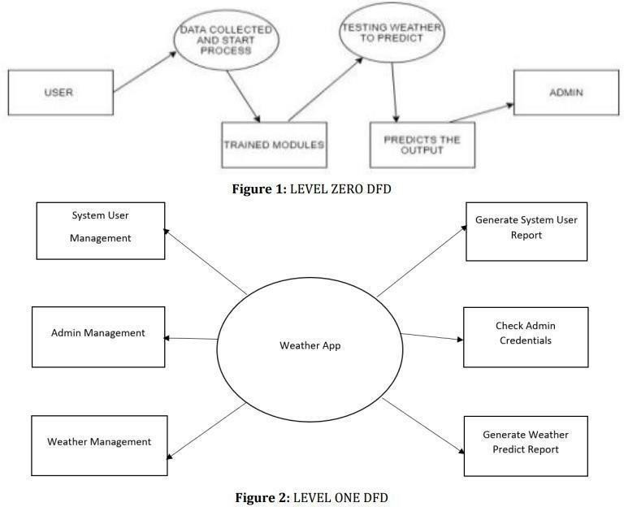

#### Use Case Diagram

The use case diagram is shown in figure 3:

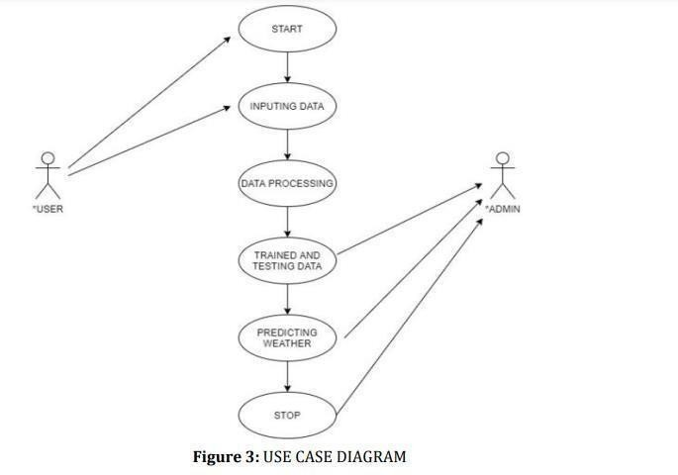

#### Application Flowchart

The application flowchart is shown in figure 4:

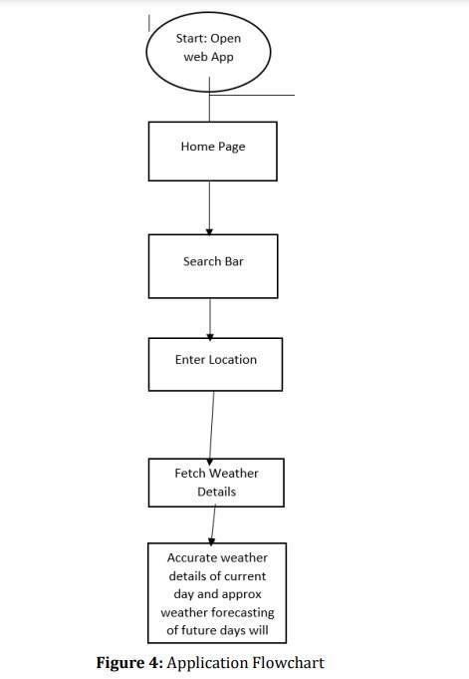

#### Sequence Diagram

The sequence diagram is shown in figure 5:

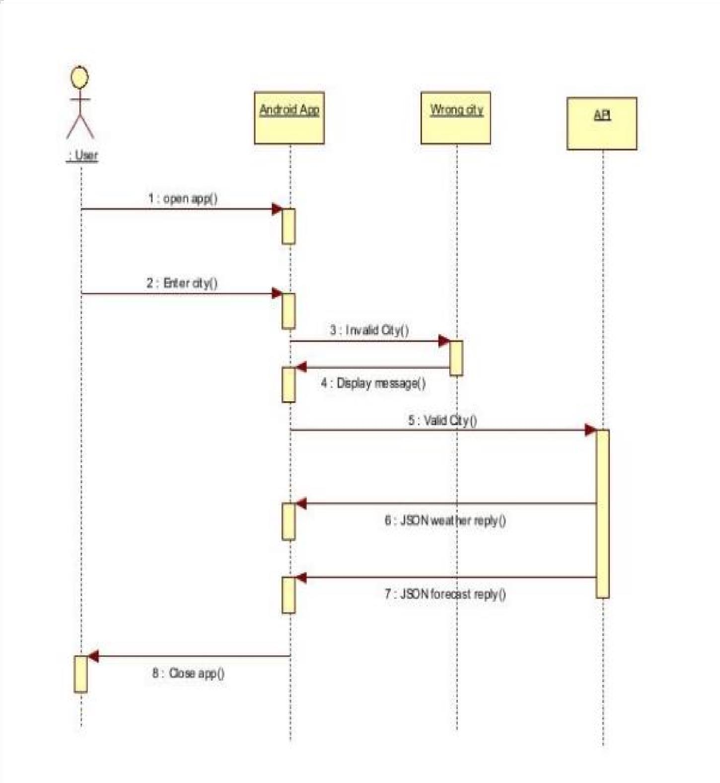

**Figure 5: S**equence Diagram

**OUTPUT:**

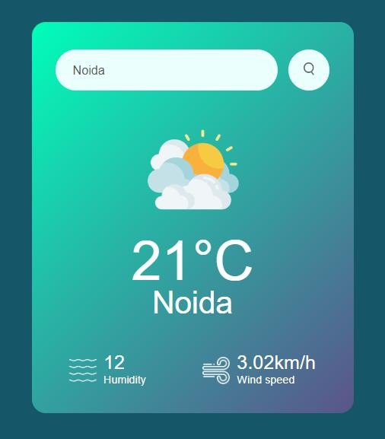

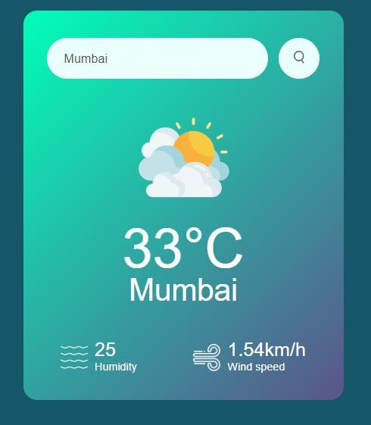

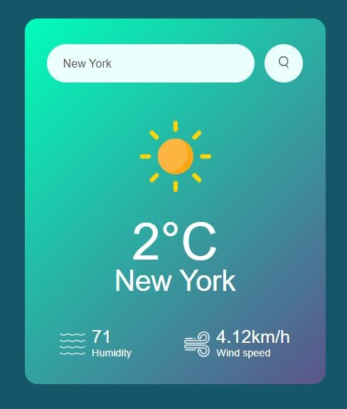

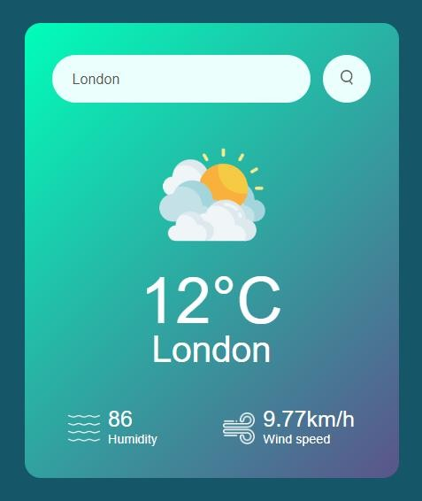

## Chapter 5: Conclusion and Future scope

#### Conclusion

From this we can conclude that a weather application can be of great help to users, especially with the increasing use of smartphones and the convenience they provide. Weather applications can be developed for various platforms, but due to the large user base of Android, developing an Android weather app would allow for access to a larger customer base. Android apps are also comparatively cheaper and more accessible, making it easier for users to have access to the app. The weather application will provide users with real-time weather information, forecasts, and other weather-related data, which can help them make better decisions about their day-to-day activities. Additionally, the weather app can provide users with statistical information and trends, which can help them monitor weather patterns over time and make data-driven decisions.

Now a day’s there is a big demand of different types of applications, which is because IT has become the main part of our New World. There is a big need of different applications. People want application for every specific task from work to entertainment. We have developed the application **“Weather WebApp”** which works easy on any given web browser.

The application has been tested and found to be working as per the given criteria. It can be safely concluded that the application possesses a highly efficient UI system and is working properly and meeting to all the requirements of the user.

The values of all the weather parameters are displayed using OpenWeathermap API’S. It is observed that there are rapid changes in the weather conditions so dynamic monitoring of these weather parameters is essential. This application can be very helpful for the farmers to use weather forecast and accordingly plan their activities.

#### Future Scopes

One potential development is the improvement in accuracy through the use of advanced data collection and analysis techniques, as well as sophisticated algorithms. This will lead to more reliable weather forecasts, helping individuals and organizations make informed decisions. Personalization is another area where weather applications are likely to evolve. These apps will offer customized forecasts and alerts based on a user's location, preferences, and behavior. This personalization will make weather information more relevant and useful for the user. Finally, weather applications will become more intuitive and user-friendly, using visualizations and other tools to help users understand complex weather data more easily

In the future the following may be added to the app:

* + - More options so that we could view temperature in ranges like forecast for seven days, for a month and detailed weather all throughout the day

. • In case of an upcoming weather calamity in your region, it should be able to show some notifications to alert the user ahead of time.

* + - The application has only one language English right now, but in the future we might even add more languages to make it more user friendly.
    - It could display the sunrise and sunset times.
    - To make it more interactive, we can add a feature of time lapse, so that we can view images of change in the climate at regular intervals.
    - Humidity and visibility
    - Image of changes



# References:

1. W3Schools: This website is one of the most popular and comprehensive resources for learning HTML and CSS. It provides tutorials, examples, and references for all aspects of web development, including HTML, CSS, and JavaScript. <https://www.w3schools.com/>
2. MDN Web Docs This website is a project by Mozilla, and it provides comprehensive documentation and tutorials for web development technologies, including HTML and CSS.
3. https://en.wikipedia.org/wiki/Android_Studio .
4. Open WeatherMap - Provides weather data API and sample codes for various platforms. https://openweathermap.org/

**CERTIFICAT OF COMPLETION**

